Bruker Fourier300 NMR Spectrometer
Sample solution height 4.5 cm with sample fully dissolved in a deuterated solvent.
Sign log book. Open Bruker TopSpin software. (Icon on desktop, user NMR.)
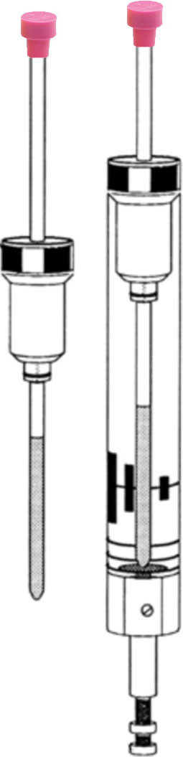
Type means click on bottom left command line, type command, then press enter/return.
Inserting Sample (Check that the black dust cap has been removed and ro off.)
- To eject previous sample, type ej | or click on Acquire in the top menubar,  then select Sample in the next line,  then select Turn on sample lift air (ej).
- Remove the previous sample and spinner floating at the top center of the NMR.
Slide the old sample out of the spinner, and slide your sample into the spinner.
← Use the plastic depth gauge to set the appropriate solution height by pushing
the sample tube through the spinner gently to the bottom of the gauge.
Put your tube with spinner into the NMR opening. It should float.
- To lower the sample, type ij (inject) | or click on Acquire in the top menubar,  then select Sample in the next line,  then select Turn off sample lift air (ij).
You will hear a click as the sample is properly positioned in probe.
Defining Sample and Experiment
- Type new or CTRL N | or click on Start in the top menubar,  then select Create Dataset in the next line.
- Enter information for your sample in the boxes at the far right of the window.
NAME – Folder name should be your last name. This will create or add to a folder.
EXPNO – Increment this number each time you run a sample.
PROCNO – This value must remain “1”.
Experiment – For ¹H, use PROTON. For ¹³C, use C13CPD (decoupled protons with NOE) or C13DEPT135 (CH and CH₃ positive, CH₂ negative) or C13DEPT90 (only CH) or C13GD (coupled protons with NOE “gated decoupling”).
Set solvent – Choose solvent from the drop down menu, usually CDCl3.
Leave Execute getprosol and Keep Parameters unchecked.
DIR – C:\Bruker\TopSpin3.2\data\coursename from menu.
Leave Receivers set to 1.
TITLE – Enter sample name for the printed spectrum.
- Click OK at bottom right. If you get an error, be sure you incremented EXPNO.
Locking, Spinning, and Shimming
1. Look at bottom row Sample to see if already spinning. If not spinning
Type ro on to spin (rotate) sample | or click on Acquire in the top menubar,  then select Spin in the next line,  then select Turn sample rotation on (ro on).
Wait for SPIN ON in the bottom left of main window.
2. Look at bottom row Lock to see if already locked. If solvent changed or if not locked
Type lock or lock cdcl3 | or click on Acquire in the top menubar,  then select Lock in the next line.
The Solvents Table window will pop up. Choose your solvent, usually CDCl3.
The trace will scan back and forth in the lock window at far right. Higher is better. If lock window is missing, type lockdisp. If offscale, type bsmsdisp and adjust lock gain.
Wait for lockn finished in the bottom left of main window but moving the cursor clears the message. At the bottom right a green check after the word “locked” also indicates success. If the lock is way off, type flock.
3. Shimming should be done once a week or if solvent has changed.
Type gradshim (solvent with single deuterium peak, lock, ro on) | or click on Acquire in the top menubar,  then click Shim in the next line.
Wait for gradshim: finished. This may take minutes. If you get a good shim set that you want to remember, type wsh to save or rsh to recall. Include date in filename.
Longer option: Type bsmsdisp or double left click on BSMS status at window bottom to manually adjust shims (starting with z¹ and z²) by clicking on Step+ or Step– to maximize lock signal. Type ro off before adjusting x or y.
Collecting Data
- Update pulse width and power levels.  Type getprosol | or click on Acquire in the top menubar,  then select Prosol in the next line.
- Type ns to set the number of scans or select AcquPars in the spectrum window. For samples that dissolve well, use 4 or 8 for proton, 64 for DEPT, 128 or 256 for carbon.
Options: Type ased or select AcquPars to modify parameters like delay time (D1).
Type expt to see time required. Type showpp to view the pulse sequence.
- Type xaua | or click on Acquire in the top menubar, then select Gain, wait, then select Go.
Watch progress at bottom left (rga, zg) and number of scans at bottom center.
- Option: To see the FID, click on Acquire in the top menubar, then click on Fid in the Spectrum window. Type prnt in bottom command line to print the active window.
- Option: If ns is large, you might type tr to transfer collected data to a temporary file. Process Spectra as listed next. If enough data has been acquired, type halt to stop.
Processing Spectra
- Select Process/Proc. Spectrum to Fourier transform, phase, and reference (ef, apk, sref).
Frequent Option: Right click on the spectrum to select Show Full Spectrum.
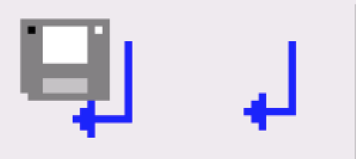
- When you enter a process mode, different icons appear at the top of the spectrum window. To exit a mode, click on the Save+Return icon to keep changes or the Return icon to discard changes. Optional: Type .ph or select Process/Adjust Phase or type . Right click at one end of the spectrum and select Set Pivot Point. Click on the 0 icon in the upper left and left drag vertically to adjust the phase of peaks near the pivot point; click on the 1 icon in the upper left and left drag vertically to adjust the phase of the rest. Exit the mode.
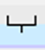
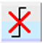
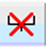
Optional: Type .cal or select on Process/Calib. Axis. Left click on TMS or known (solvent) peak. Enter the chemical shift value for that peak.
Optional: Type .pp or select Process/Pick Peaks. Select the field goal icon, then left drag a box that includes peak tops. To delete all, click the X icon. Exit the mode.
Optional: Type .int or select Process/Integrate. Select the field goal icon, then left drag across each peak to integrate. To set an integral value, right click on a peak and select Calibrate Current Integral. To delete all, click the X icon. Exit the mode.
- Type plot or click Plot on the Spectrum toolbar (if Plot is absent, did you exit any previous mode?) A useful layout file to open is Beloit.xwp. Click on spectrum then at left Axes Grids, Curve. Set Plot limits x: 12 –0.5 for proton or 250 –10 for carbon.
- To create inset plots, click outside the dotted margins of the plot. Insert new elements by clicking at left on the NMR drop down and selecting 1D spectrum. Left drag to create a new plot. Click on the new plot and edit its Plot limits.
- Type prnt or CTRL P to print  Use Landscape orientation. | or click on Publish in the top menubar, then select Print in the next line.
When finished, type ro off. See inserting sample to swap sample tubes.
Always store a sample in spectrometer! Complete your entry in the log book. Replace the black plastic dust cap at end of lab.
The COSY experiment relies on J-coupling where cross peaks indicate which protons are close to which other protons through bonds.
The NOESY experiment relies on direct dipolar couplings where cross peaks indicate which protons are close to which protons through space.
- First run the ¹H spectrum and remember which EXPNO.
- Then type new or CTRL N or select Start/Create Dataset.
Select Experiment COSYGPSW or NOESYGPPHSW.
Increment EXPNO. Modify TITLE. OK.
Type ro off or Acquire/Spin/Turn sample rotation off (ro off) since 2-D experiments should always be run without rotation.
Type getprosol or select Acquire/Prosol.
- Select Acquire/Set Limits. Left drag the previous ¹H spectrum name in the browser window into the spectrum window. Left drag over the entire peaks with 0.2 ppm of baseline at both ends. OK. Verify SW and O1P are properly set. Close.
- For NOESY type ased or select AcquPars in spectrum window and click . Change D8 to 0.450.
- Type rga, wait, then zg or select Acquire/Gain, wait, then select Acquire/Go.
COSY takes about 5 minutes with 1 scan and 128 increments.
NOESY takes about 50 minutes with 4 scans and 256 increments
- Select Process/Proc. Spectrum.
Use mouse scroll wheel to adjust the contour levels. Type .ls to save levels.
- Type plot or click Plot on the Spectrum toolbar. A useful layout file to open is Beloit2D.xwp.
- Type prnt or CTRL P or select Publish/Print.

The HSQC experiment relies on the large JHC coupling constant to correlate the chemical shift of a proton with the chemical shift of its directly bonded carbon.
- First run the ¹H spectrum and remember which EXPNO.
- Then type new or CTRL N or select Start/Create Dataset.
Select Experiment HSQCGPPH. Increment EXPNO. Modify TITLE. OK.
Type ro off or Acquire/Spin/Turn sample rotation off (ro off) since 2-D experiments should always be run without rotation.
Type getprosol or select Acquire/Prosol.
- Select Acquire/Set Limits. Left drag the previous ¹H spectrum name in the browser window into the spectrum window. Left drag over the entire peaks with 0.2 ppm of baseline at both ends. OK. Verify SW and O1P are properly set. Close.
- Type rga, wait, then zg or select Acquire/Gain, wait, then select Acquire/Go. This takes about 15 minutes with 2 scans and 256 increments.
- Select Process/Proc. Spectrum. Low resolution 1D projections are displayed at the top (¹H) and left (¹³C) of your spectrum. If you have full spectra, right click on the projection and select External Projection. Select the appropriate EXPNO. Show Spectra Thumbnails in the Browser window for the Last50 might help.
- Use mouse scroll wheel to adjust the contour levels. Type .ls to save levels.
- Type prnt or CTRL P or select Publish/Print.

Some calculations
Type sinocal to calculate the signal to noise ratio for a spectrum.
Type hwcal to calculate the width of a peak at half height.
Type diffe to calculate the difference spectra between expnos.
The inversion-recovery experiment measures spin-lattice T1 relaxation times where a 180° pulse is followed by spectra collected at various delay times,
- First run the ¹H spectrum.
- Then type new or CTRL N or select Start/Create Dataset.
Select Experiment PROTONT1. Increment EXPNO. Modify TITLE.
Type ro off or Acquire/Spin/Turn sample rotation off (ro off).
Type getprosol or select Acquire/Prosol.
- Select Acquire/Set Limits. Do not answer the dialog. Left drag the previous ¹H spectrum name in the browser window into the spectrum window. Left drag over just the peaks with 1.0 ppm of baseline at both ends. The solvent peak may be excluded if it falls outside of the region of interest. OK. Verify SW and O1P are properly set. Close.
- Select AcquPars in the spectrum window and perhaps click or .
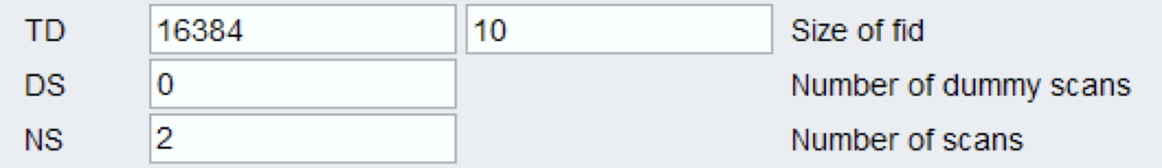
Set up for 10 data points:

Click E to edit list:
0.1, 0.2, 0.5, 1, 2, 4, 6, 8, 12, 16. Select File/Save. Select File/Close.
Also check D1 value. The default is 15. D1 + AQ should be greater than 10 x T1.
- Select Acquire/Gain, wait, then select Acquire/Go. This takes about 8 minutes.
- Type rser 10 (last data row, if successful screen will say 1d raw data available). Type ef (Fourier transform). Type apk (phase).
Type .2d or click 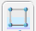. (If successful screen will say 2D raw data available. Click on Fid in the spectrum window to see the 10 sets of data.)
Type xf2. Type abs2.
- Type t1t2 or select Analyse/TopSpin T1/T2 Module.
Click Fid. Enter maximum slice number 10 since 10 values in VDLIST. OK.
Click Peaks/Ranges.
Click Manual Integration. OK.
Define regions by dragging over each peak of interest.
Click. Export Regions To Relaxation Module and .ref.
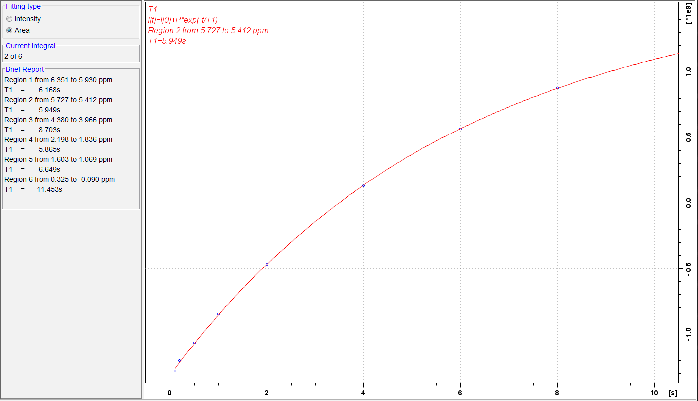
Click Relaxation. OK.
Click Fitting.
Select fitting type Area. Close then OK.
Click Calculation. Close then click .
Use to step through all the peaks.
Type prnt or CTRL P for each peak.
Click Report if you want to see data table.

Proton 90 Degree Pulse p1
- Run a one scan ¹H spectrum. Expand to include one peak (can be a multiplet).
- Click on . Left click on the peak center to set RF. Click on .
- Right click on the expanded peak. and Save Display Region to...’
Enable Parameters F1/2. OK.
- Select ProcPars in the spectrum window
SI = 8192
LB [Hz] = 1
PH_mod = pk
- Select AcquPars in the spectrum window and perhaps click or .
PULPROG = zg (not the normal zg30)
TD = 16384
SW [ppm] =10
D1 [sec] = 20 (long value so completely relaxes before next pulse)
DS = 0
NS = 1
- Type ro off or Acquire/Spin/Turn sample rotation off (ro off).
- Select Acquire/Gain, wait, then select Acquire/Go.
- Click on the down arrow in Process/ 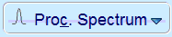.
Select Configure Standard Processing (proc1d).
Select:  Exponential Multiply (em)  Auto-Phasing (apk) | Deselect:  Set Spectrum Reference (sref)  Auto-Baseline correction (absn)  Warn if Processed data exist
Execute.
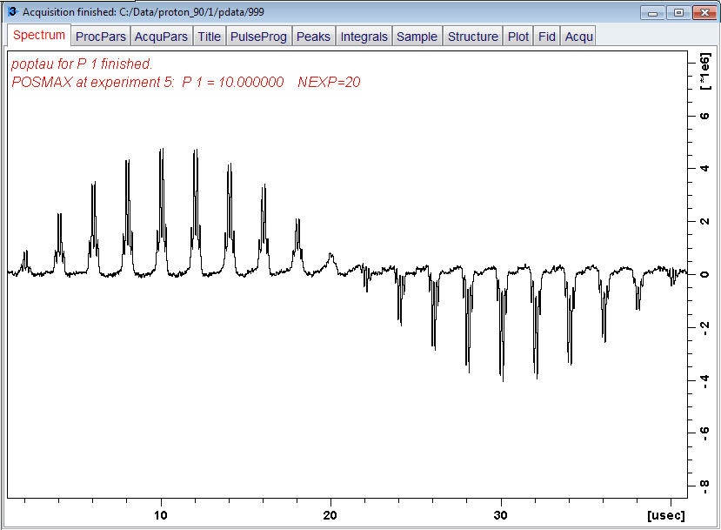
- Type popt or click on the down arrow in Acquire/ 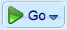.
Choose Optimize Acquisition Params (popt).
OPTIMIZE = Step by step
Obtain 20 spectra incrementing 90° pulse width p1 from 10 usec by 2 usec.
GROUP
PARAMETER = p1
OPTIMUM = POSMAX
STARTVAL = 10
ENDVAL
NEXP = 20
VARMOD = LIN
INC = 2
- Click on Start Optimize. Save. y. OK.
Data is collected 20 times with a long wait between scans. Takes about 8 minutes.
The zoomed region is plotted side-by-side in procno 999. Look for the spectrum closest to the null point. This is 180 or 360°. Divide time to get the 90° pulse.
- When trf: finished, switch to Spectrum view.
Click to move baseline to center. Use mouse wheel to adjust the vertical height.
- Repeat popt, changing values to pin down the zero crossing.
- Type prnt or CTRL P or select Publish/Print.

